# ACW Lab Screenshots

Part 1

PWD Command – Exercise 2

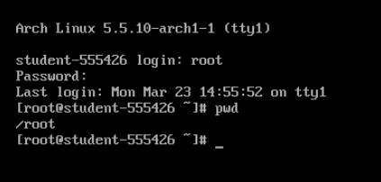

Touch & LS Command – Exercise 2

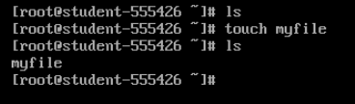

Install Man & Nano – Exercise 2

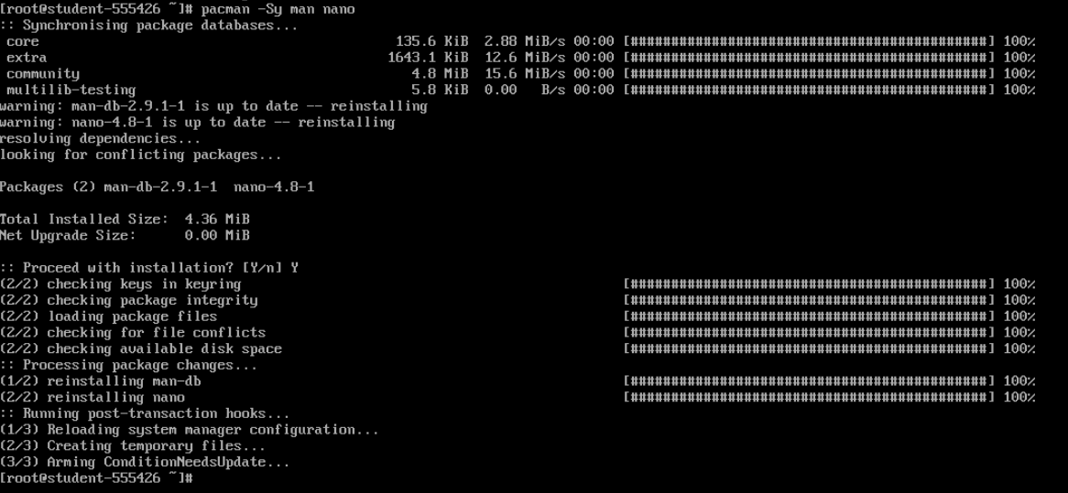

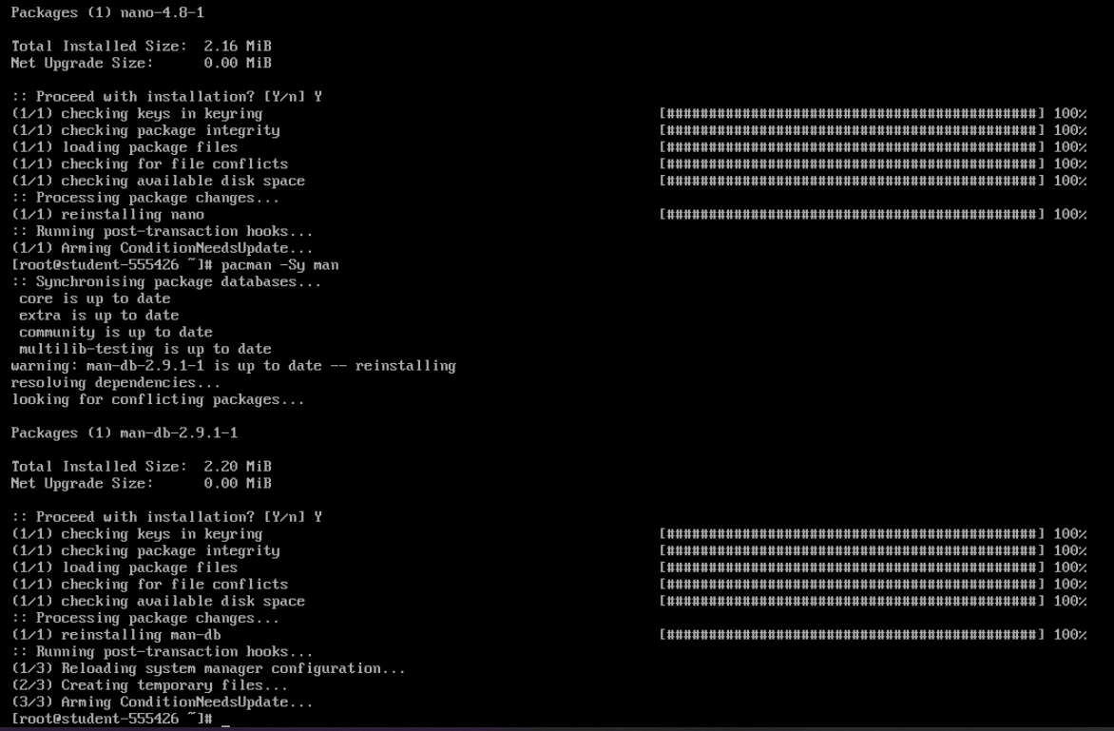

Connect to the Internet – Exercise 4 & 5

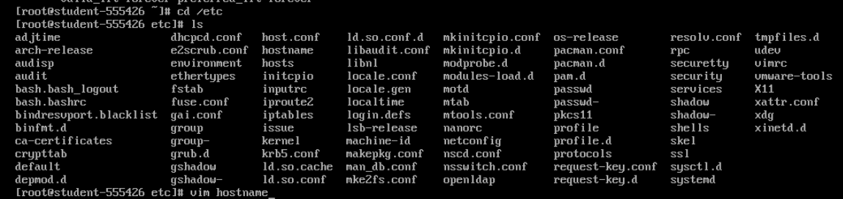

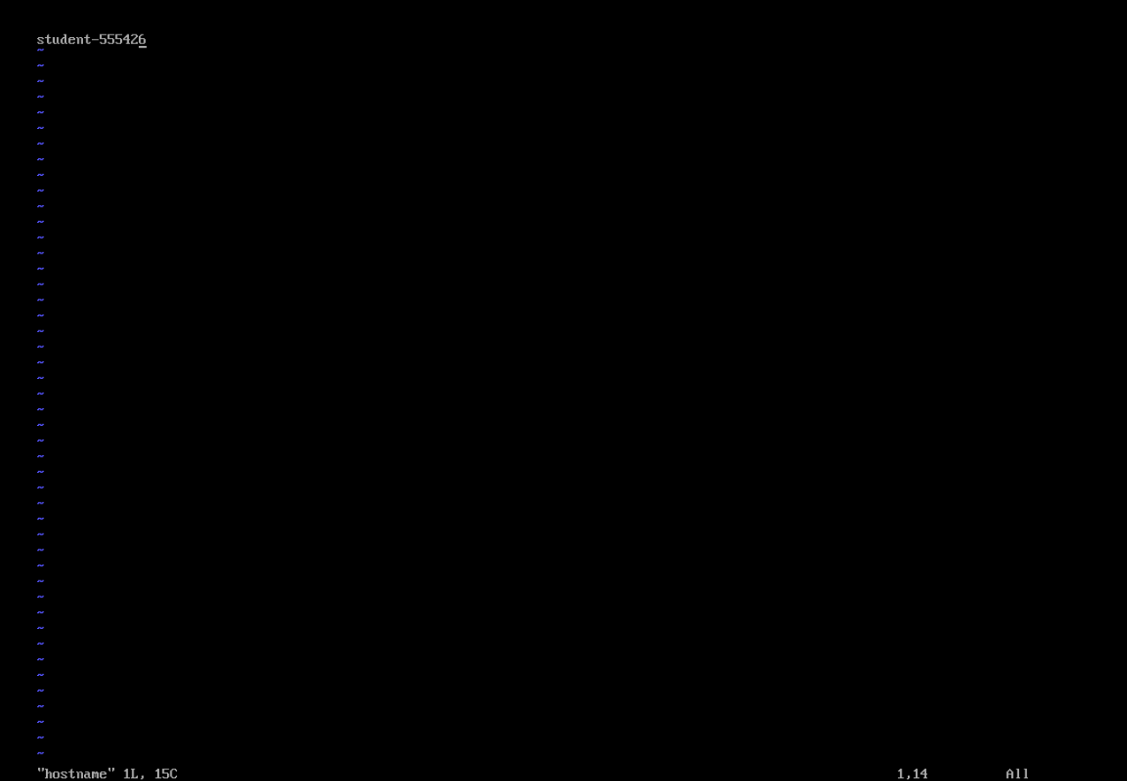



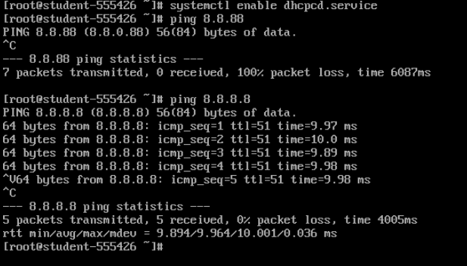

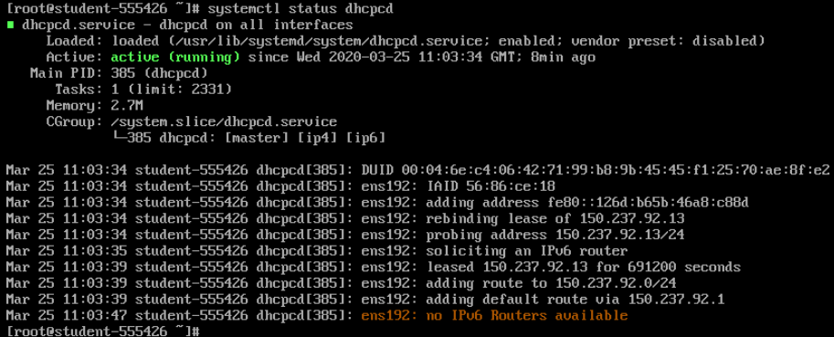

Exercise 7 – IP addr

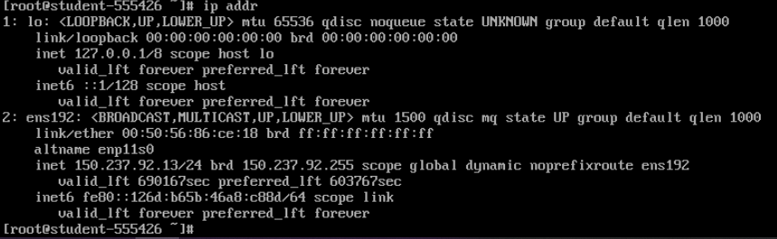

Exercise 9 – Nano

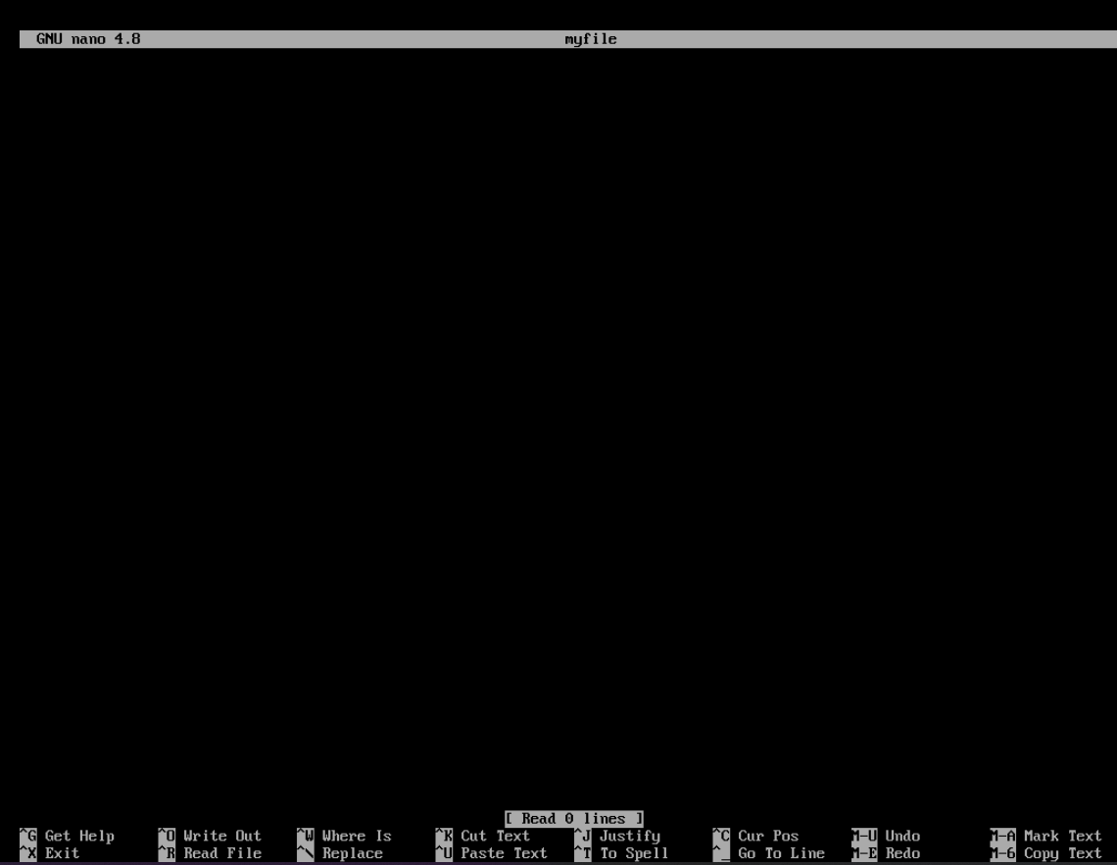

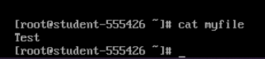

Exercise 10 – Manuals

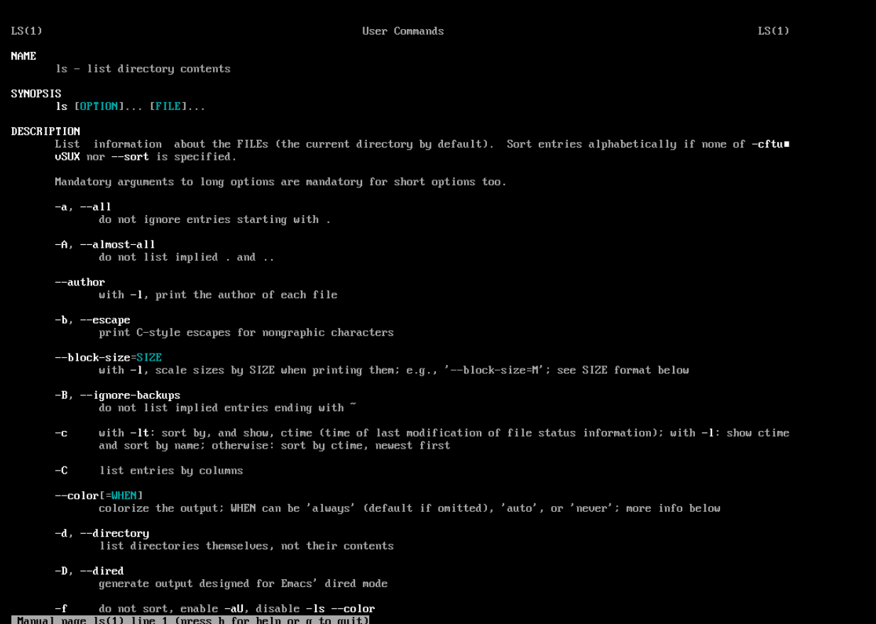

Exercise 11 – CD MOTD Nano

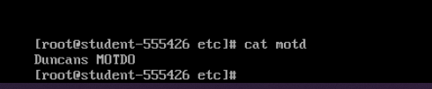

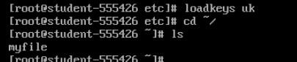



Exercise 13 – pacman

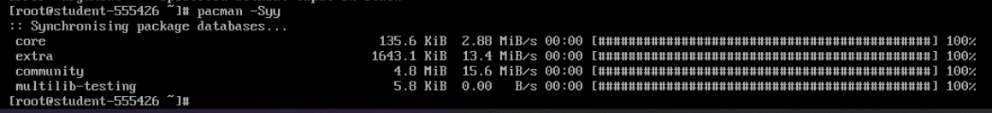

Exercise 14 – full upgrade

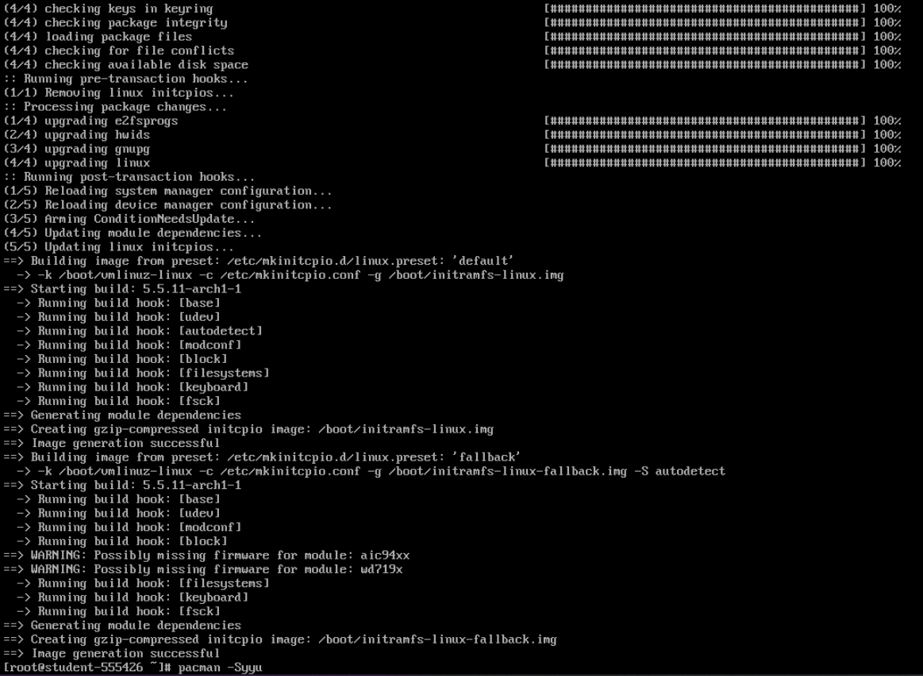

Part 2

Exercise 1 – RM

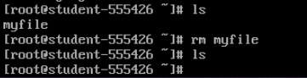

Exercise 2 – Mkdir

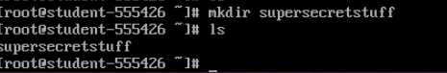

Exercise 3 – Touch files inside directory

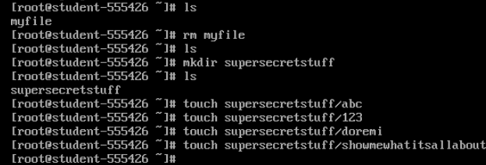

Exercise 4: Piping

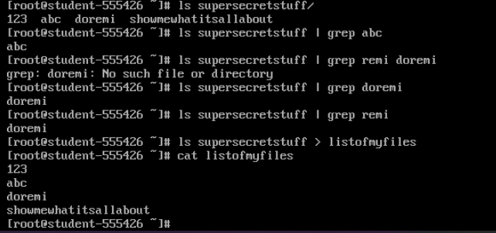

Exercise 5 – Copy



Exercise 6 – Move

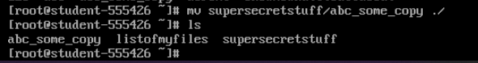

Exercise 7 – Rm expanded



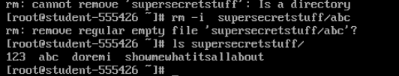

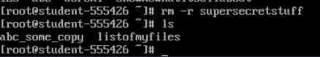

Exercise 8 – Create a user account



Exercise 9 – Changing passwords

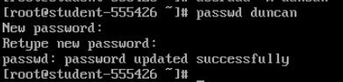

Pass: duncan

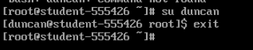

Exercise 10 – install sudo

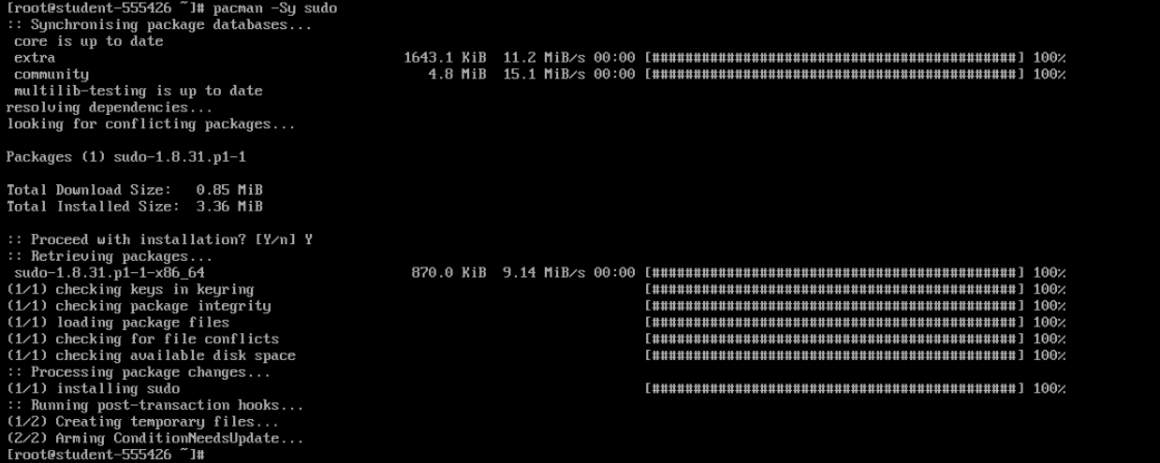

Exercise 11 – Visudo



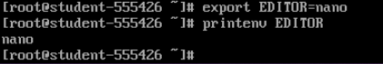

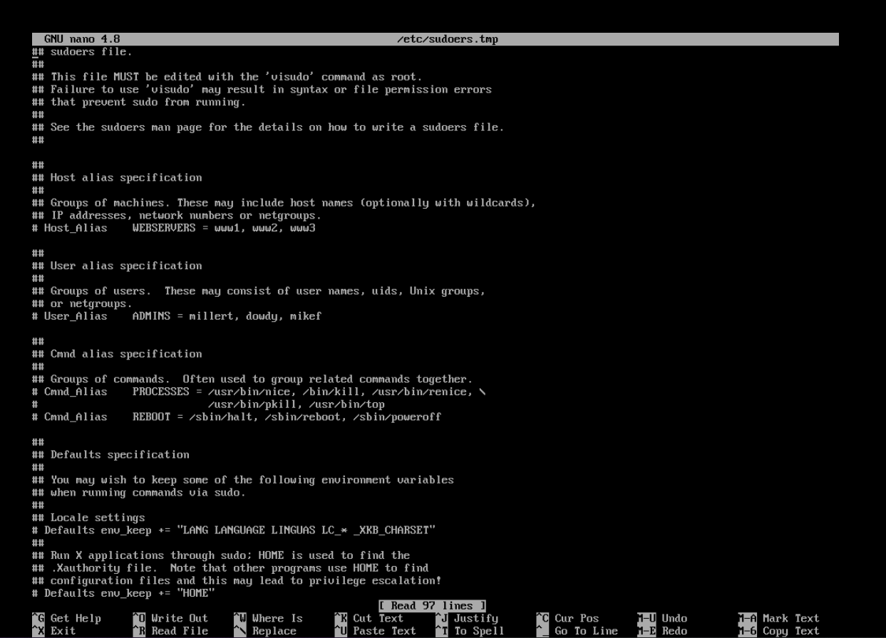

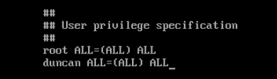

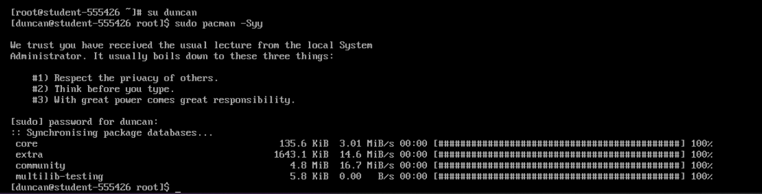

Exercise 13 – Sudo permissions

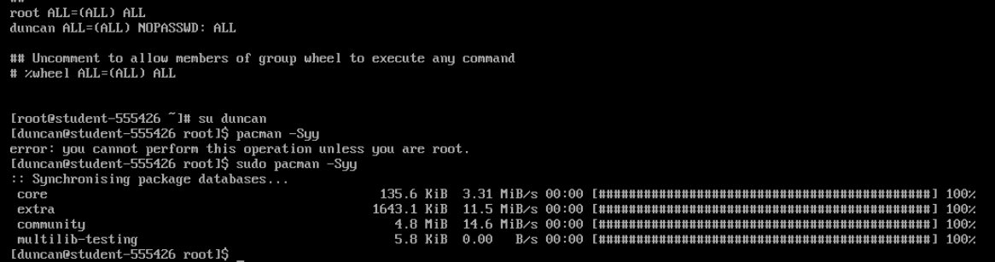

Exercise 14

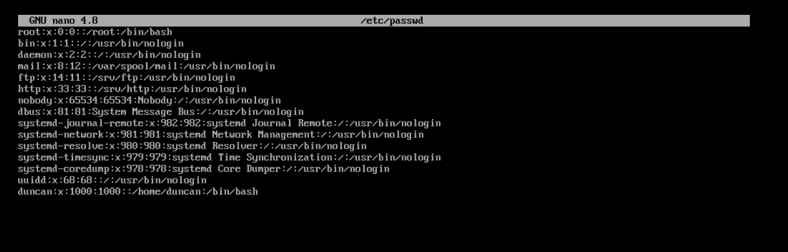

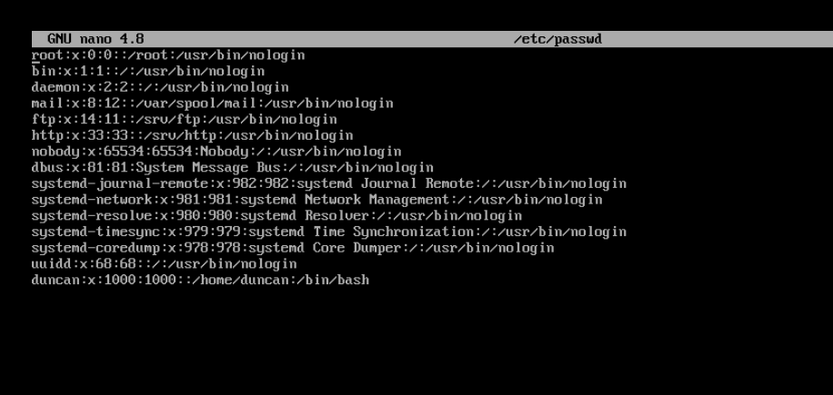

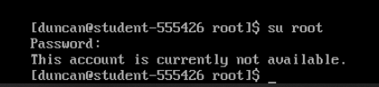

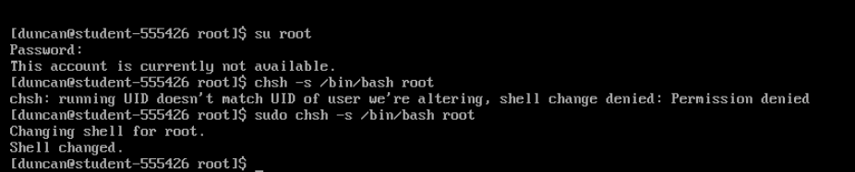

Exercise 15 – Loadkeys



Part 3

Exercise 1 – OpenSSH

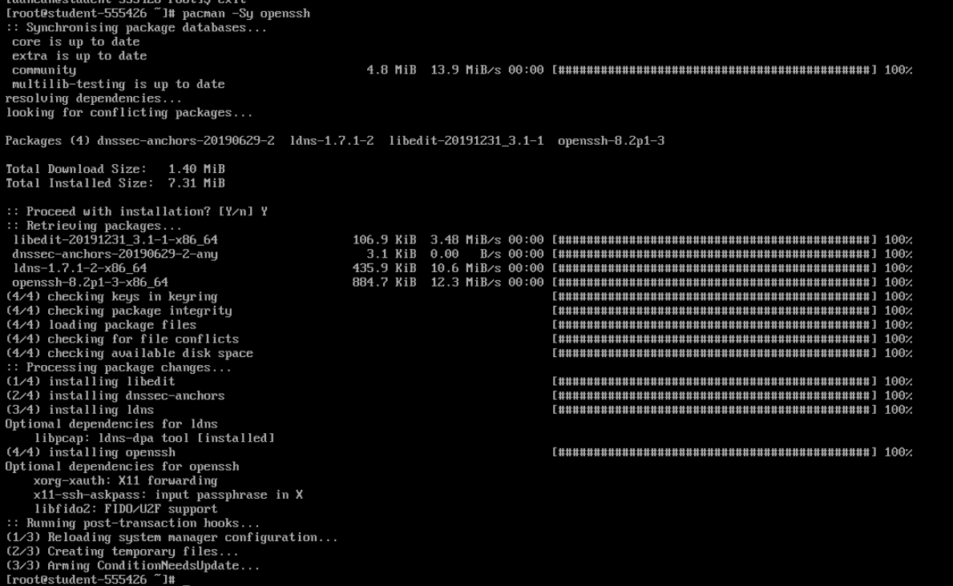

Exercise 2 – start SSHD



Exercise 4 – SSH to other VM

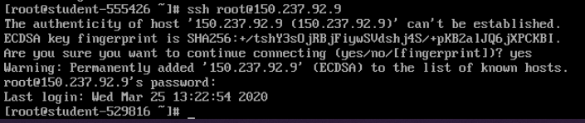

Exercise 5 – Create files through ssh

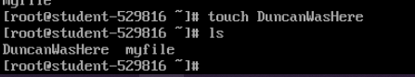

Exercise 6 – Watch LS

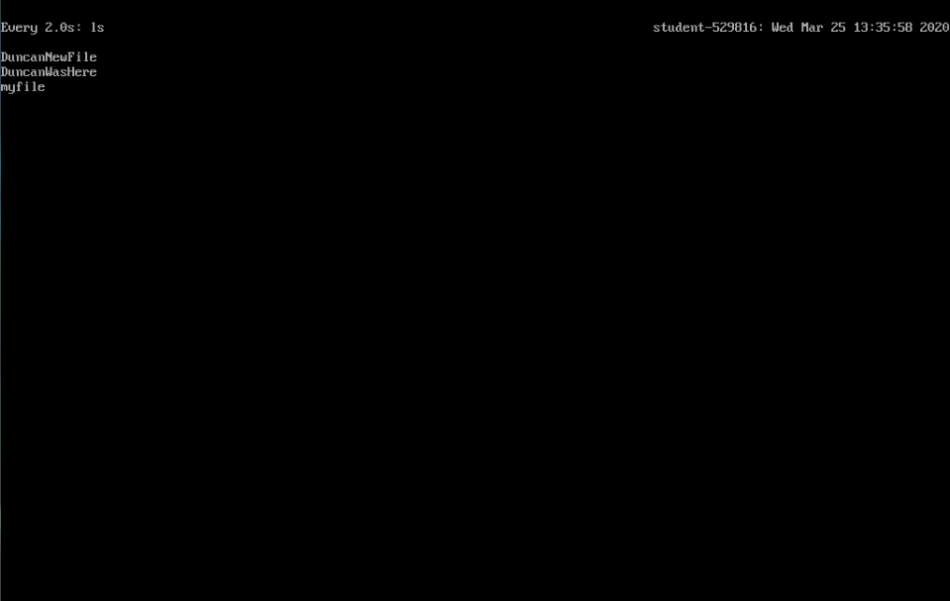

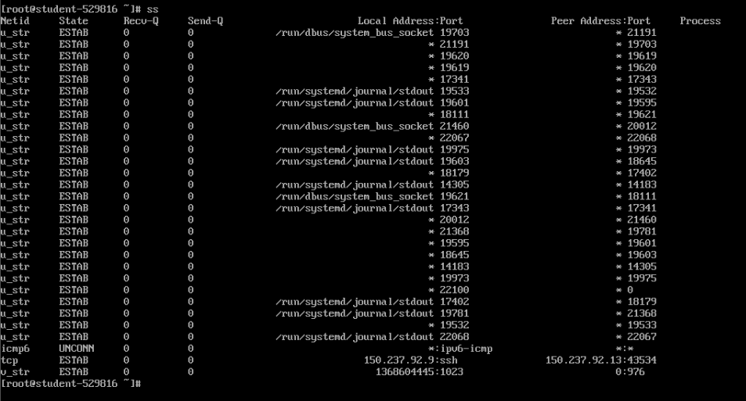

Exercise 7 – Journalctl

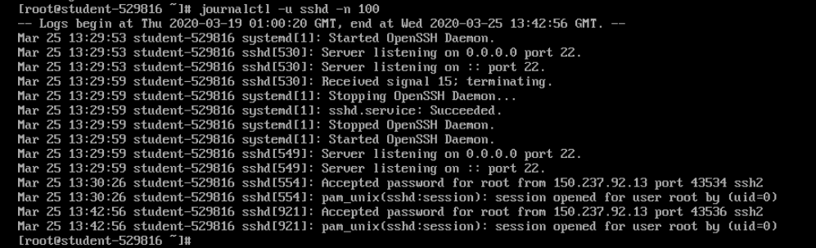

Exercise 7 – Keypair

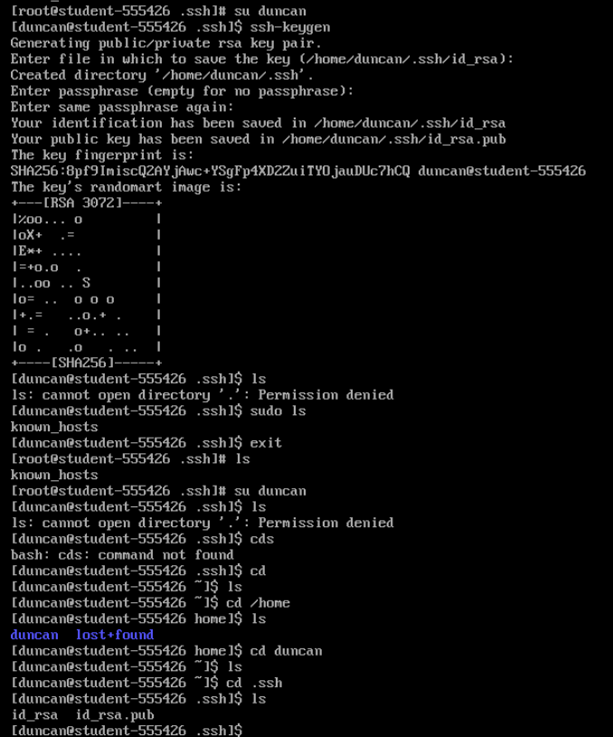

Add public key

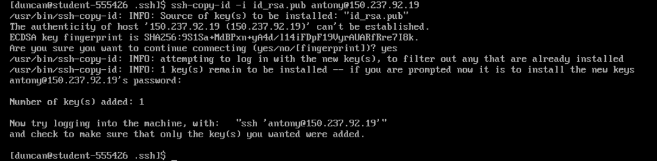

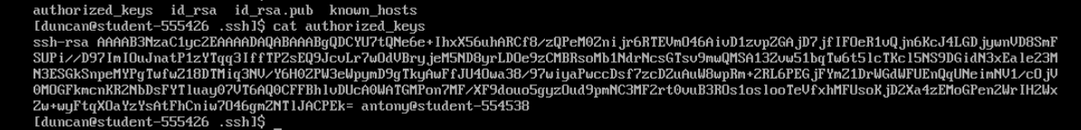

Install ashleys key using wget

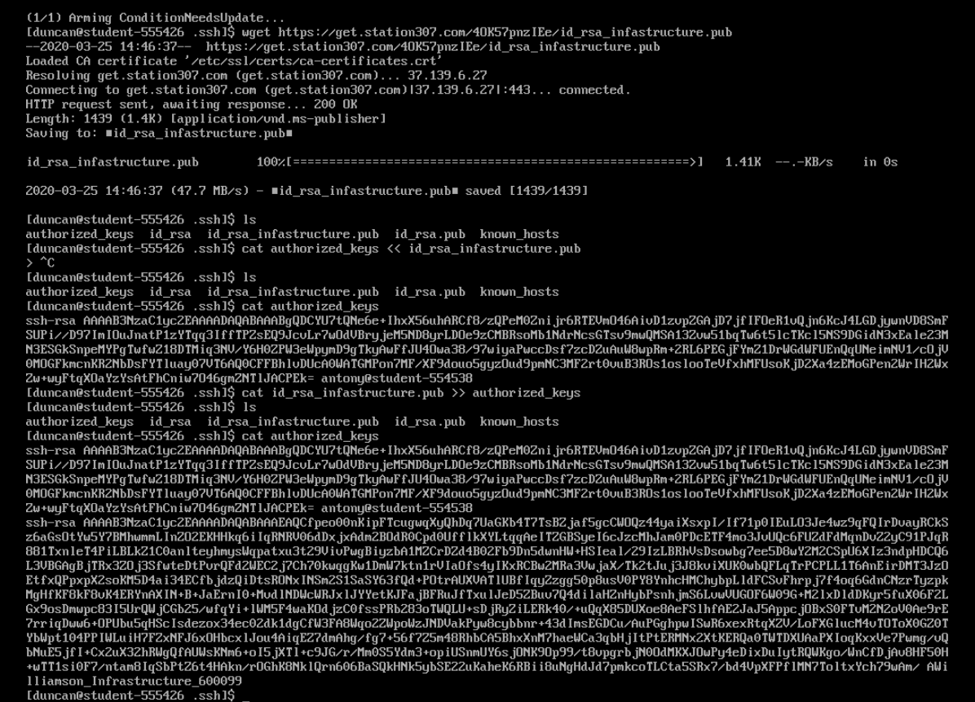

Exercise 8 – Allow users

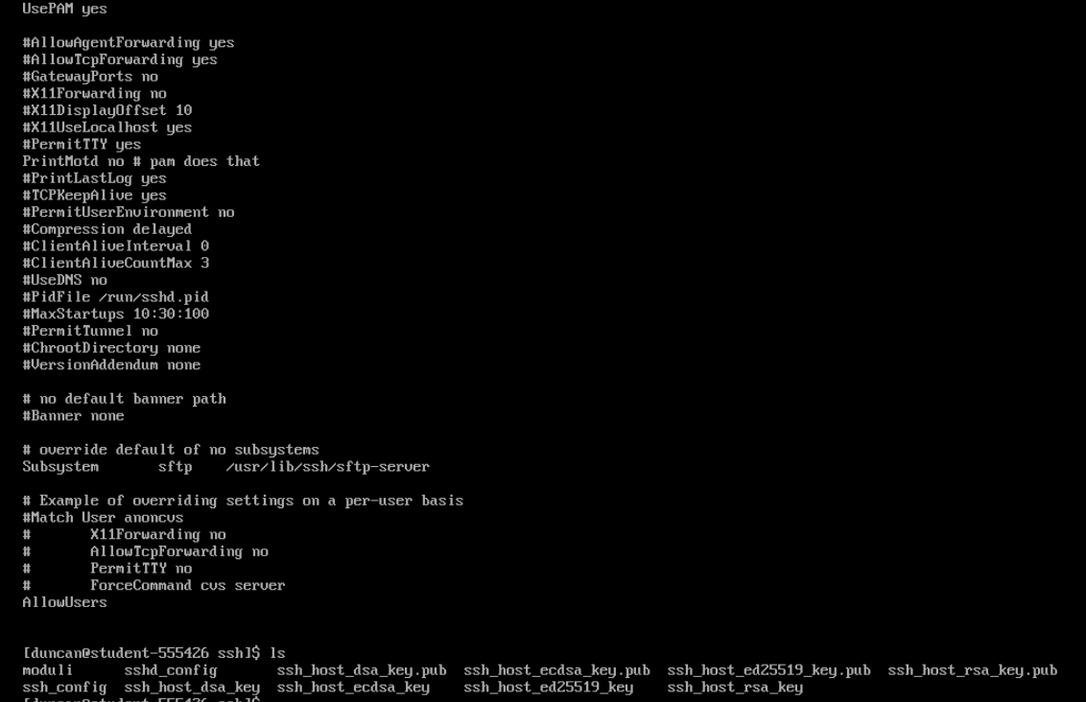

Exercise 9

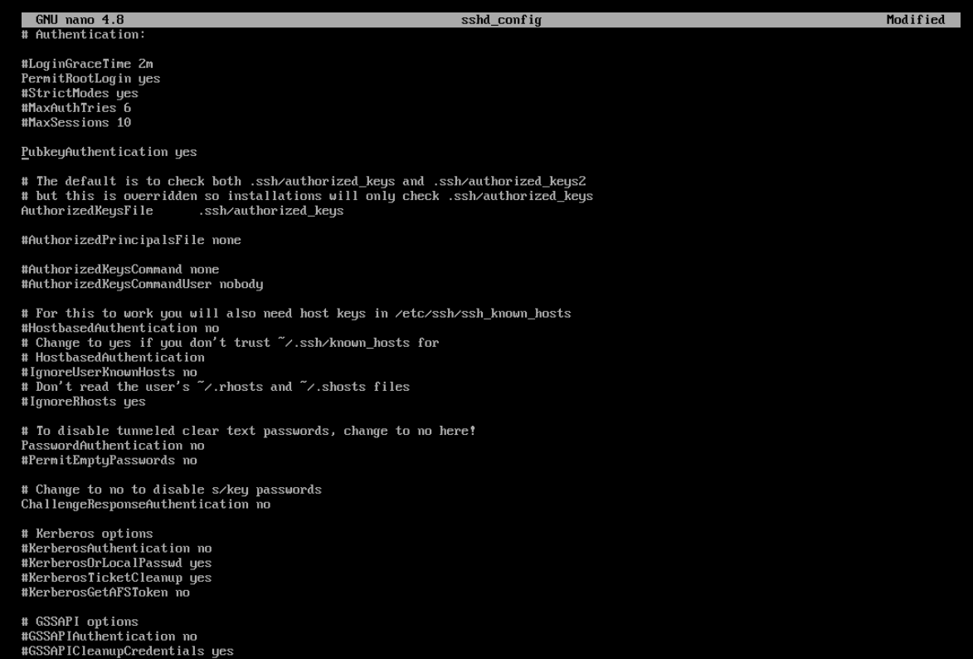

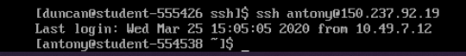

Lab 04

Exercise 1 – Create Ashley account



Exercise 2 – Create 2 users and change passwords

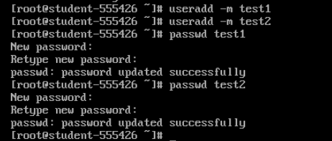

Passwords: Test 1: duncantest1 Test2: duncantest2

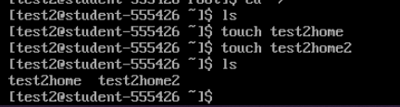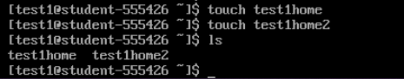



Default pass is 1000 by default these are both 1002 and 1003

Exercise 3 - Delete Users

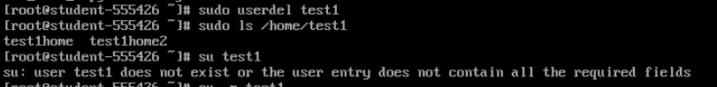

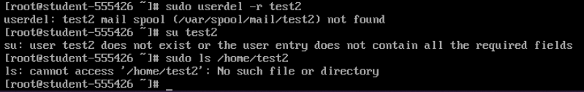

Exercise 4 create a system user

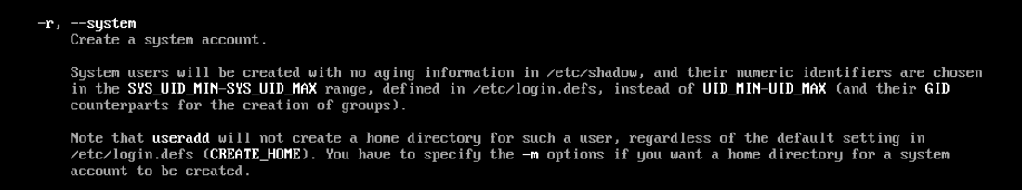

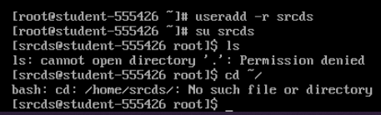

Exercise 5 – Add Ashley to wheel

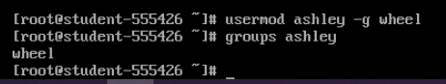

Exercise 6 – Grant wheel SUDO with password

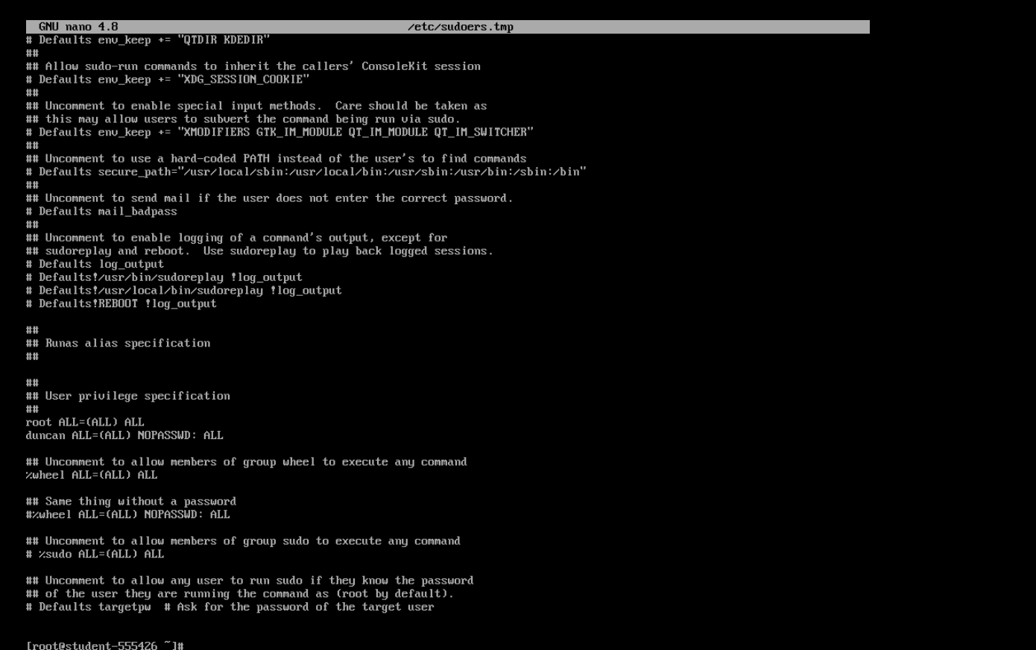

Tested by enabling no password then su Ashley user to test sudo functionality. Then went back to change to requiring a password. Testing was simple Sudo ls is a completely innocent command

Exercise 7 – add group



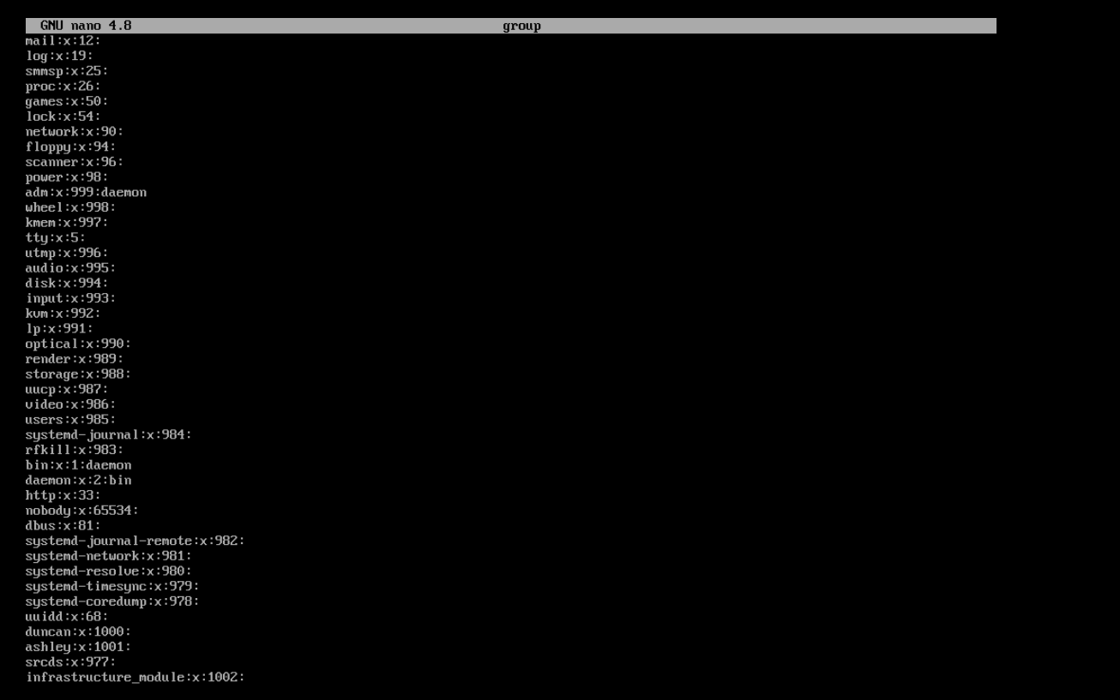

Exercise 8 – change group name



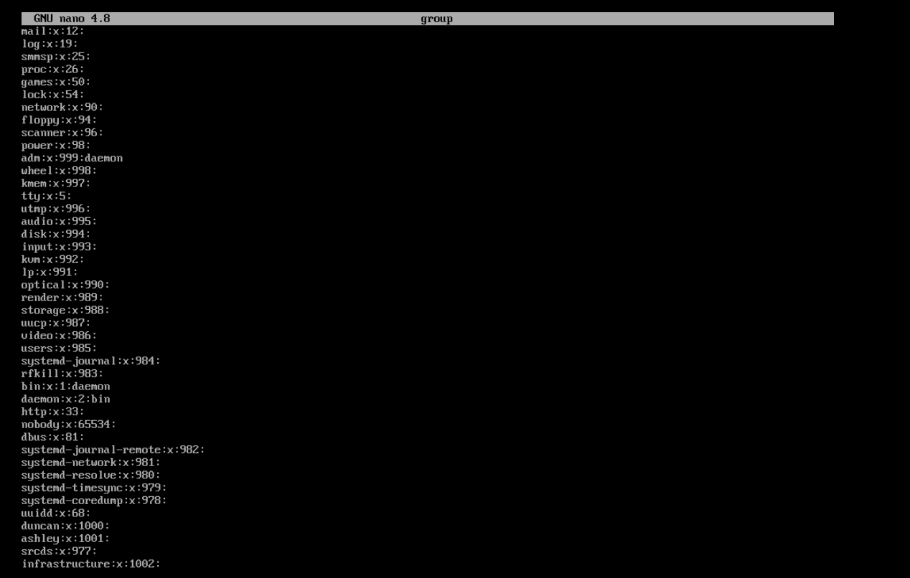

Exercise 9 – create a new directory for group

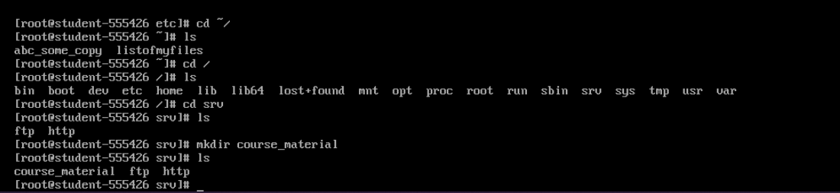



Currently everyone can do anything to this directory

Exercise 10 – Chown





Exercise 11 – Permissions

RWX RWX RWX

421 421 421

111 101 000

7 5 0

750 Octal

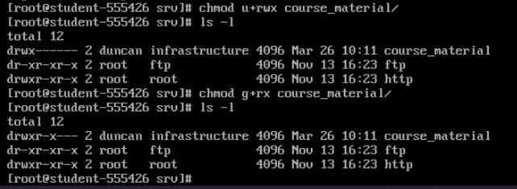

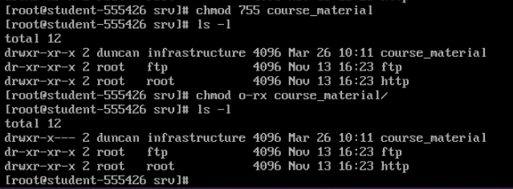

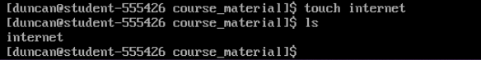

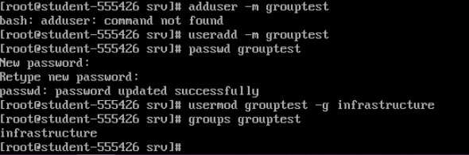

Grouptest pass: grouptest1

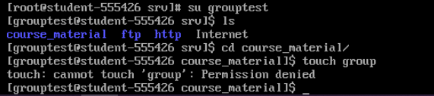

Nanoed with sudo user

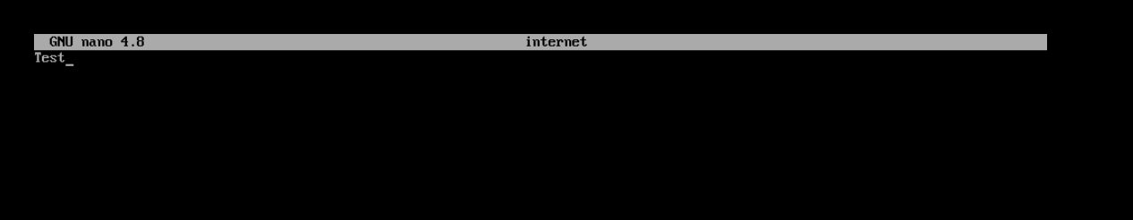

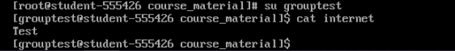

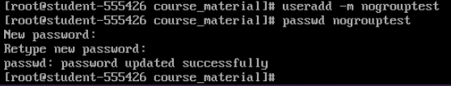

Password nogroup

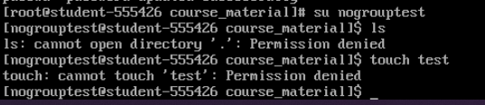

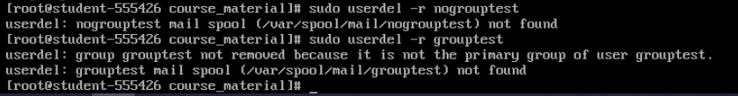

Exercise 12 – permissions 2

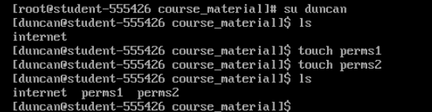

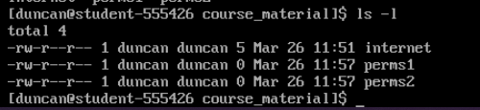

Exercise 13 – Permissions Final

Add write access to user owner

Chmod u+w file/directory

Chmod g-x file/directory

Chmod 0-rwx file/directory

